**Name: _______________________________________**

**Python Activity 13: Value Returning Functions**

|  |
| --- |
| **Learning Objectives**  Students will be able to:  *Content:*   * Explain the meaning and purpose of a value returning function * Combine the use of functions with if/else statements * Explain programs that use the same function multiple times * Use good test data for programs that include functions   *Process:*   * Write code that includes function definitions and function calls * Write programs that incorporate functions and if/else statements   **Prior Knowledge**   * Python concepts from Activities 1-12a |

**FYI:** So far, the functions you have created print the results within the function. They do not send back any information to the original calling code. Functions that do not send back information are known as **void functions**. Functions often send back or *return* a result and are known as **value returning functions**.

1. Enter and execute the code below. Carefully examine the code.

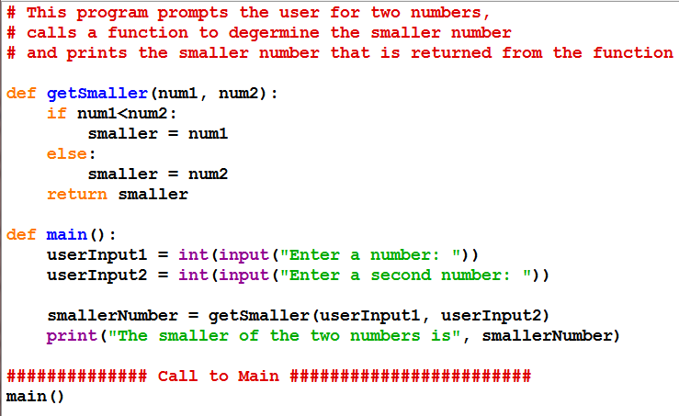



a. What is the new **keyword** used in the function definition? What do you think the keyword tells the program to do?

return. It tells get smaller to send the variable smaller back to main as smaller Number

b. Circle the line of code from the program that includes the **function call** to *getSmaller*.

c. In a **void function,** the **function call** is on a line by itself. Why is this **function call** placed on the right-hand-side of an **assignment statement**?

Because the other function runs inside the first one and returns a value for the first one to use

d. What are the arguments used for the function call? Userinput 1 and 2

2. Examine the following Python program.



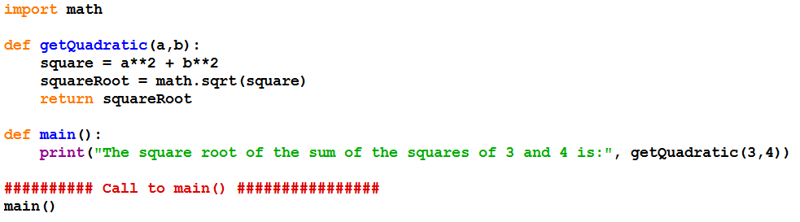

a. What does the program do?

calculates c in the Pythagorean theorem

1. Circle the function call.

c. Is the function a **void function** or a **value-returning function**? Value returning function

d. Why is the import statement needed in this program?

So we can use functions from the math library that isn’t including in base python

**Application Questions: Use the Python Interpreter to check your work**

1. Carefully examine and then complete the following *Python* program.
   * The program prompts the user to enter a number between 1 and 5
   * It also generates a random number between 1 and 5.
   * The program prints the number the user enters and prints the random number.
   * The program then compares the two numbers.
     + If the numbers are the same, it prints the message “You picked the same number as the computer!”.
     + If the number the user entered is higher than the random number, the program should print “Your number is higher than the computer’s number.”
     + Otherwise, it should print: “Your number is smaller than the computer’s number”.

**Complete the code for the *getMessage()* function so that it returns the appropriate message, depending on the values stored in the two parameters. See Sample Output for the correct messages to be returned.**

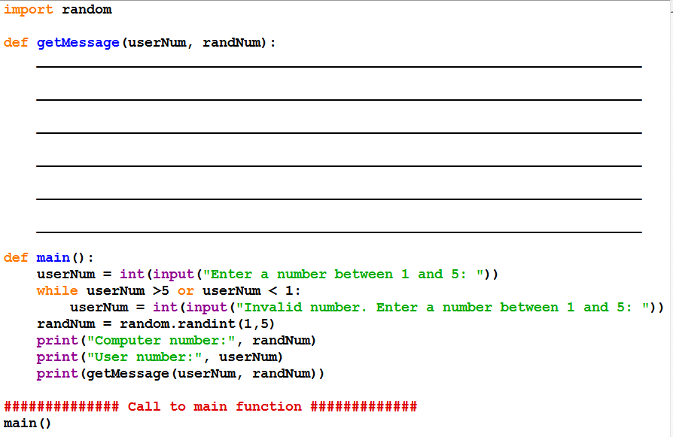

**Sample Output**

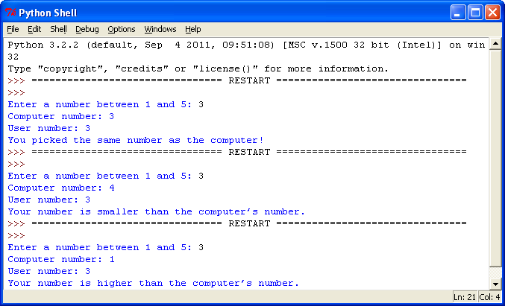

**import random**

**def getMessage(userNum, randNum):**

**if userNum == randNum:**

**return("You picked the same number as the computer!")**

**elif userNum > randNum:**

**return("Your number is higher than the computer’s number.")**

**else:**

**return("Your number is smaller than the computer’s number")**

**def main():**

**userNum = int(input("Enter a number between 1 and 5: "))**

**while userNum >5 or userNum <1:**

**userNum = int(input("Invalid number. Enter a number between 1 and 5: "))**

**randNum = random.randint(1,5)**

**print("Computer Number:",randNum)**

**print("User number:", userNum)**

**print(getMessage(userNum, randNum))**

**main()**

2. Complete the following program. The program should:

* + Display five addition facts, one at a time, and allow the user to answer them.
  + Provide the correct answer if user enters incorrect answer.
  + Print a congratulatory answer, if the answer is correct.
  + Keep track of the number of problems the user answers correctly.
  + Prints a special message, if the user gets all five problems correct.

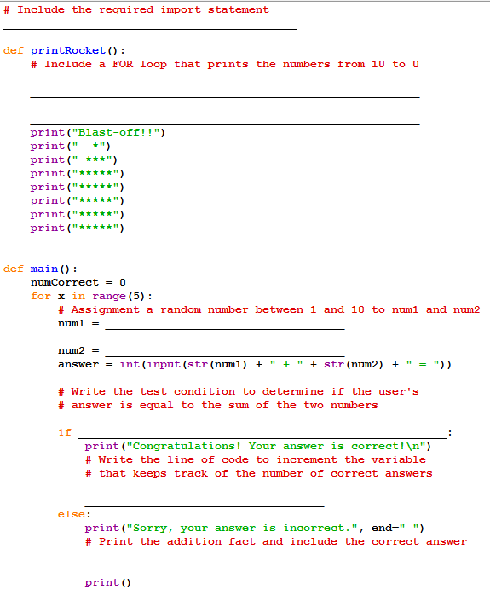

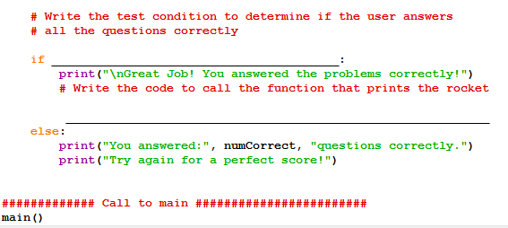

import random

def printRocket():

for x in range(10,-1-1):

print()

print(x)

print()

print("Blast-off!!")

print(" *")

print(" ***")

print("*****")

print("*****")

print("*****")

print("*****")

print("*****")

def main():

numCorrect = 0

for x in range(5):

num1 = random.randint(1,10)

num2 = random.randint(1,10)

answer = int(input(str(num1) + " + " + str(num2) + " = "))

if answer == num1+num2:

print("Congratulations! Your asnswer is correct!\n")

numCorrect+=1

else:

print("Sorry, your answer is incorrect.", end=" ")

if numCorrect==5:

print("\nGreat Job! You answered the problems correctly!")

printRocket()

else:

print("You answered", numCorrect, "questions correctly.")

print("Try again for a perfect score!")

main()